Project Design Phase-I Problem – Solution Fit

|  |  |
| --- | --- |
| Date | 10 OCTOBER 2022 |
| Team ID | PNT2022TMID01023 |
| Project Name | IoT Based Safety Gadget for Child Safety  Monitoring & Notification |
| Maximum Marks | 2 Marks |

# Problem – Solution Fit:

The Problem-Solution Fit simply means that you have found a problem with your customer and that the solution you have realized for it actually solves the customer’s problem. It helps entrepreneurs, marketers and corporate innovators identify behavioral patterns and recognize what would work and why

# Purpose:

* Solve complex problems in a way that fits the state of your customers.
* Succeed faster and increase your solution adoption by tapping into existing mediums and channels of behavior.
* Sharpen your communication and marketing strategy with the right triggers and messaging.
* Increase touch-points with your company by finding the right problem-behavior fit and building trust by solving frequent annoyances, or urgent or costly problems.

# Understand the existing situation in order to improve it for your target group.

**Problem-Solution fit:**

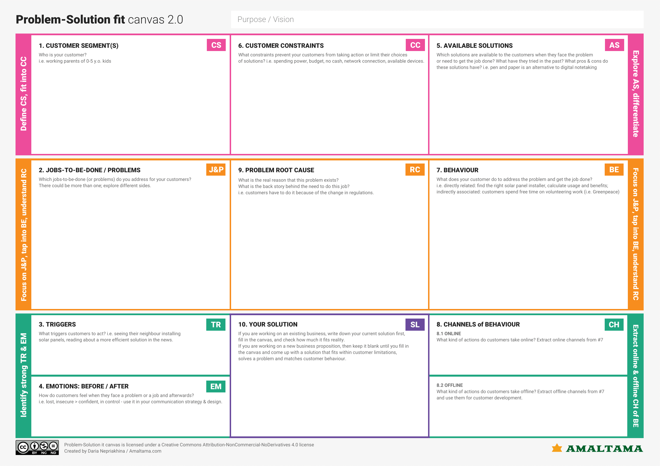

Parents or guardians of 5–

15-year-old kids.

Budget, availability of

devices, reliability

The existing solutions are

very costly or follow a subscription-based model

Reduce the cost, make it

more user friendly

Parents have to do this

because of increasing child related crimes

Talk with other parents about

things related to child safety

Scared > Peace of mind

They lookout for the areas that are safe

To create a device which costs low and is more user friendly

Listening to news related to child crimes

Drop and pick up the child straight from the location like school and park